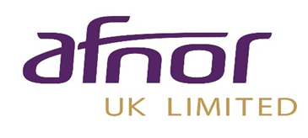
Branding Guidelines

The United Kingdom Accreditation Service (UKAS) is the only organization designated by the UK Government (Department for Business, Energy, and Industrial Strategy) to accredit certification bodies within the UK. This accreditation is widely regarded as the benchmark of excellence for certifying ISO standards and is the sole means by which an organization can display the prestigious, government-endorsed national accreditation mark,

UKAS offers a range of accreditations; however, our specific accreditation as a certification body is for ISO 17021-1:2015. Just as certification bodies evaluate organizations against management system. UKAS evaluates certification bodies against ISO 17021-1:2015. This standard ensures that we are competent in assessing the management systems we evaluate.

We operate under a regulated framework and undergo comprehensive annual audits. This rigorous process ensures that UKAS's "seal of approval" is highly respected and significantly enhances the credibility of the AFNOR UK as a certification body.

We take pride in displaying the UKAS mark, also known as the Crown and Tick, alongside our own logo.

Furthermore, the companies we certify are permitted to use the AFNOR UK certification badges to showcase their accomplishment. They may also display the combined AFNOR UK/UKAS logo, if desired, provided they comply with the conditions outlined in this guide.

WHERE YOU CAN USE CERTIFICATION BADGES

Before using any of our certification badges, please review and ensure you understand the usage guidelines outlined in this guide. If you have any questions or need clarification, please reach out to your account manager.

Where to display your certification Badge
 | UKAS CERTIFIED | NON-UKAS CERTIFIED
Products | X | X
Flags | X | ✓
Vehicles | X | ✓
Building Externals | X | ✓
Stationery | ✓ | ✓
Website | ✓ | ✓
Internal Walls and Doors | ✓ | ✓
Exhibition stands | ✓ | ✓

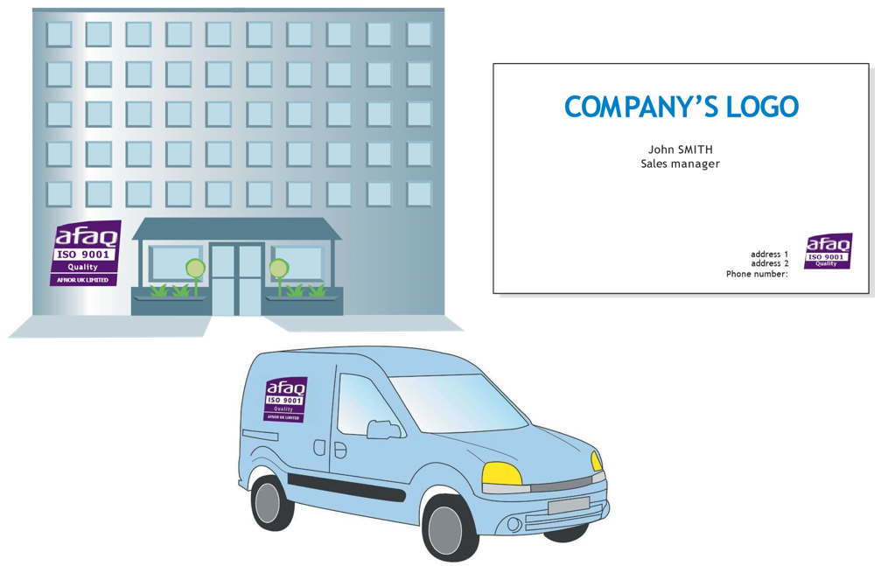

Certification badges must remain in their original format and may not be modified in any way. Altering the design or colour of the certification badge is not permitted. If you require the logo in a different size or format, please contact us using the email address provided below.

The certification badge must not be used in a manner that could mislead readers regarding the certified scope of an organization.

Any use of the certification badge or official logos that violates the conditions outlined in these guides or UKAS guidelines will be referred to AFNOR UK.

The certification badge must not be used in a manner that suggests AFNOR UK accepts responsibility for activities conducted within the scope of a client's certification.

In the event of suspension or termination of any AFNOR UK certification, certified organizations must immediately stop using any materials displaying the certification badge. This includes, but is not limited to, removing certification badges from websites, stationery, and vehicles. The requirement applies to all instances where the badge is displayed.

UKAS Certified badges

The UKAS-accredited certification badge includes the AFNOR UK logo, the name of the standard, and the type of management system that has been certified.

The certification badge may only be used by companies that have obtained UKAS-accredited certification for the specified standard. The badge is provided at a size of 60mm x 60mm and should not be used if the text becomes unreadable. The UKAS logo must always be displayed alongside the certification badge, never on its own, and must measure between 20mm and 30mm unless used on a document larger than A4. Use of this logo is subject to UKAS conditions, which must be followed when displaying the badge.

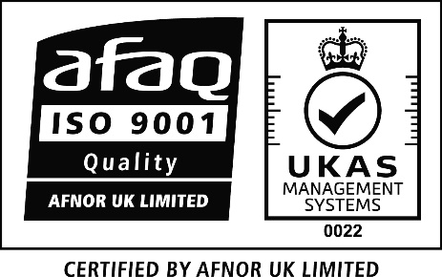
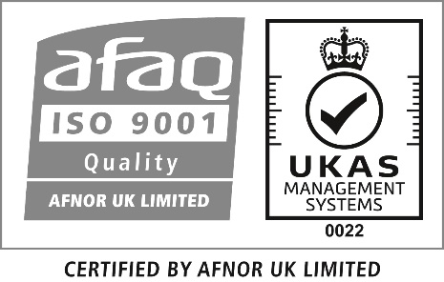
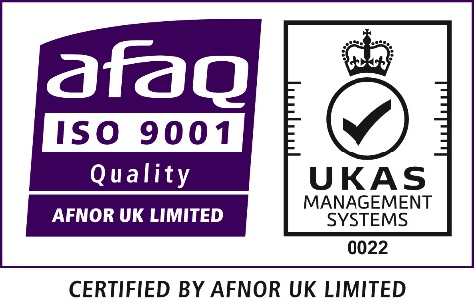

NON-Certified badges

The non-UKAS certification badge includes the AFNOR UK logo, a tick mark, the name of the standard, and the type of management system certified. This badge may be used by companies that have achieved certification for the specified standard but are not UKAS-accredited. It is provided at a size of 60mm x 60mm and should not be used if the text becomes unreadable.



